**CST 316-2: Statistical Methods - II**

**Design and Analysis of an Experiments**

**Assignment-05**

**Department of Computer Science and Informatics**

**Uva Wellassa University of Sri Lanka**

**Q1.**

|  |  |  |  |  |
| --- | --- | --- | --- | --- |
| **Temperature (0C)** | **Stain of Yeast** | | | |
| **1** | **2** | **3** | **4** |
| **12** | 130 | 115 | 52 | 61 |
| 118 | 118 | 43 | 74 |
| **16** | 105 | 106 | 80 | 101 |
| 105 | 116 | 70 | 98 |
| **20** | 88 | 131 | 93 | 96 |
| 130 | 121 | 99 | 78 |

**a.**

**𝑦𝑖𝑗 = 𝜇 + 𝜏𝑖 + 𝜌𝑗 + 𝜏𝜌𝑖𝑗 +𝜀𝑖𝑗**

𝑖 = 1,2,3

𝑗 = 1,2,3,4

𝑦𝑖𝑗 = the observation in ith temperature and the jth yeast

𝜇 = overall mean

𝜏𝑖 = the effect of the ith temperature

𝜌𝑗 = the effect of the jth yeast

𝜏𝜌𝑖𝑗=interaction effect of ith temperature and jth yeast

𝜀𝑖𝑗 = random error

General Linear Model: Acidity versus Temperature, Yeast

method - Factor coding (-1, 0, +1)

Factor Information

|  |  |  |  |
| --- | --- | --- | --- |
| **Factor** | **Type** | **Levels** | **Values** |
| Temperature | Fixed | 3 | 12, 16, 20 |
| Yeast | Fixed | 4 | 1, 2, 3, 4 |

Analysis of Variance

|  |  |  |  |  |  |
| --- | --- | --- | --- | --- | --- |
| **Source** | **DF** | **Adj SS** | **Adj MS** | **F-Value** | **P-Value** |
| Temperature | 2 | 981.3 | 490.6 | 4.15 | 0.043 |
| Yeast | 3 | 8493.7 | 2831.2 | 23.96 | 0.000 |
| Temperature*Yeast | 6 | 3057.1 | 509.5 | 4.31 | 0.015 |
| Error | 12 | 1418.0 | 118.2 |  |  |
| Total | 23 | 13950.0 |  |  |  |

**Understanding Statistical Significance**

Determining the statistical significance of observable effects in our data allows us to make the distinction between real influences and chance. This choice is made using p-values in hypothesis testing.

**Effect of Temperature (τᵢ)**

Null Hypothesis (H₀): All temperatures have the same effect (τ₁ = τ₂ = τ₃).

Alternative Hypothesis (H₁): At least one temperature effect (τᵢ) is different.

The temperature's p-value is 0.043, below the significance criterion of α = 0.05, according to the Analysis of Variance Table. Thus, it appears that temperature has a major impact on acidity, and we may reject the null hypothesis.

**Effect of Yeast Strain (ρⱼ)**

Null Hypothesis (H₀): All yeast strains have the same effect (ρ₁ = ρ₂ = ρ₃ = ρ₄).

Alternative Hypothesis (H₁): At least one yeast strain effect (ρⱼ) is different.

In the Analysis of Variance Table, the yeast strain's p-value is 0.000, which is likewise less than α = 0.05. As a result, the null hypothesis can be rejected, showing that acidity is greatly influenced by distinct yeast strains.

**Interaction Effect between Temperature and Yeast Strain (τρᵢⱼ)**

Null Hypothesis (H₀): There is no interaction effect between temperature and yeast strain (τρ₁₁ = τρ₁₂ = ... = τρ₃₄).

Alternative Hypothesis (H₁): At least one interaction effect (τρᵢⱼ) is different.

The interaction between yeast strain and temperature has a p-value of 0.015, which is smaller than α = 0.05. As a result, we reject the null hypothesis and propose that acidity is strongly influenced by the interplay between yeast strain and temperature.

Modal Summary

|  |  |  |  |
| --- | --- | --- | --- |
| **S** | **R-sq** | **R-sq(adj)** | **R-sq(pred)** |
| 10.8704 | 89.84% | 80.52% | 59.34% |

**b.** Interaction Plot for Acidity

The way that yeast strain and temperature interact affects acidity greatly. This indicates that the impact of temperature on acidity differs according on the type of yeast. More specifically, strains 2 and 3 exhibit an increase in acidity at higher temperatures, whereas strains 1 and 4 exhibit a decrease in acidity as temperature rises.

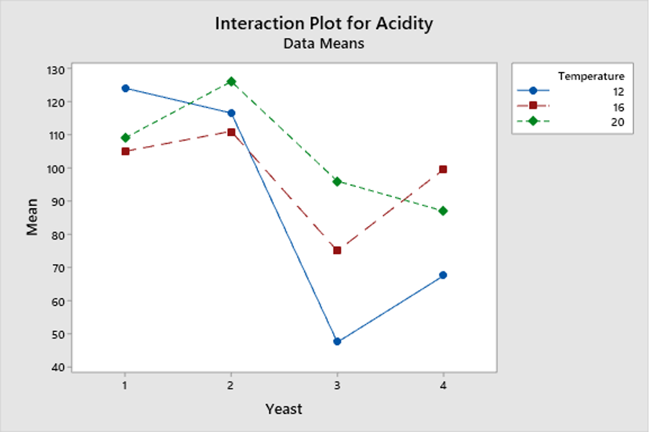

**c.** Comparisons for Acidity

Tukey Pairwise Comparisons: Temperature

Grouping Information Using the Tukey Method and 95% Confidence

|  |  |  |  |  |
| --- | --- | --- | --- | --- |
| **Temperature** | **N** | **Mean** | **Grouping** | |
| 20 | 8 | 104.500 | A |  |
| 16 | 8 | 97.625 | A | B |
| 12 | 8 | 88.875 |  | B |

Tukey Pairwise Comparisons: Yeast

Grouping Information Using the Tukey Method and 95% Confidence

|  |  |  |  |  |
| --- | --- | --- | --- | --- |
| **Yeast** | **N** | **Mean** | **Grouping** | |
| 2 | 6 | 117.833 | A |  |
| 1 | 6 | 112.667 | A |  |
| 4 | 6 | 84.667 |  | B |
| 3 | 6 | 72.833 |  | B |

**Interpretation:**

1. **Yeast 2 and Yeast 1:**

**Hypotheses:**

H0: ρ1 = ρ2

H1: ρ1 ≠ ρ2

**Result:** Yeast 1 and Yeast 2 share the same letter grouping (A), indicating no significant difference in their means. Do not reject H0.

1. **Yeast 1 and Yeast 3:**

**Hypotheses:**

H0: ρ1 = ρ3

H1: ρ1 ≠ ρ3

**Result:** Yeast 1 and Yeast 3 do not share a letter grouping (A and B), indicating a significant difference in their means. **Reject H0.**

1. **Yeast 1 and Yeast 4:**

**Hypotheses:**

H0: ρ1 = ρ4

H1: ρ1 ≠ ρ4

**Result:** Yeast 1 and Yeast 4 do not share a letter grouping (A and B), indicating a significant difference in their means. **Reject H0.**

1. **Yeast 2 and Yeast 4:**

**Hypotheses:**

* + - H0: ρ2 = ρ4
    - H1: ρ2 ≠ ρ4

**Result:** Yeast 2 and Yeast 4 do not share a letter grouping (A and B), indicating a significant difference in their means. **Reject H0.**

1. **Yeast 3 and Yeast 4:**

**Hypotheses:**

H0: ρ3 = ρ4

H1: ρ3 ≠ ρ4

**Result:** Yeast 3 and Yeast 4 share the same letter grouping (B), indicating no significant difference in their means. **Do not reject H0.**

1. **Yeast 2 and Yeast 3:**

**Hypotheses:**

H0: ρ2 = ρ3

H1: ρ2 ≠ ρ3

**Result:** Yeast 2 and Yeast 3 do not share a letter grouping (A and B), indicating a significant difference in their means. **Reject H0.**

**Predictions Based on Tukey Pairwise Comparisons:**

Whether the means of various yeast strains differ significantly from one another is shown by the letter groupings. In the event the strains have the same letter, there is no significant difference in their means; if not, there is a substantial difference.

**Temperature:**

The mean acidity peaks at 20°C (104.5), which is considerably different from 12°C but not from 16°C. This implies that temperatures above a certain point tend to result in acidity levels that are greater and closer to the desired 100 units.

The moderate temperature of 16°C has acidity levels that are not appreciably different from those of 20°C or 12°C.

The least amount of acidity, 88.875, is found at 12°C; this is significantly different from 20°C but not from 16°C.

**Yeast Strain:**

The greatest mean acidity levels (117.833 and 112.667, respectively) are produced by yeasts 2 and 1, which do not differ substantially from one another. Higher acidity levels can be achieved with these strains.

The mean acidity levels produced by yeasts 4 and 3 are much lower than those of yeasts 1 and 2, at 84.667 and 72.833, respectively. If reaching acidity levels near to 100 units is the aim, then these strains might not be appropriate.

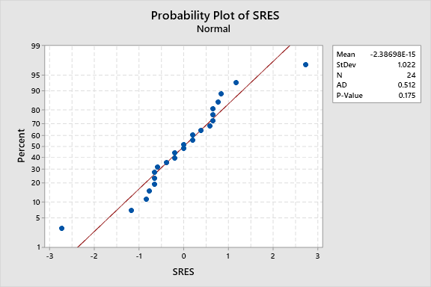

**Hypothesis Testing for Residuals Normality**

**Hypothesis:**

* **Null Hypothesis (H₀) -**The residuals follow a normal distribution.
* **Alternative Hypothesis (H₁) -**The residuals do not follow a normal distribution.

**Result:**

* **P-Value -** 0.175

The null hypothesis (H₀) cannot be ruled out because the p-value (0.175) is higher than the significance level (0.05). This suggests that the residuals have a roughly normal distribution.

|  |  |  |  |
| --- | --- | --- | --- |
|  | | **Number of Observations** | |
| **N** | **K** | **≤ K** | **> K** |
| 24 | -0.0000000 | 11 | 13 |

K = sample mean

|  |  |  |
| --- | --- | --- |
| **Number of Runs** | |  |
| **Observed** | **Expected** | **P-Value** |
| 14 | 12.92 | 0.649 |

**Hypothesis:**

* **Null Hypothesis (H₀):** The order of the data is random.
* **Alternative Hypothesis (H₁):** The order of the data is not random.

**Result:**

* **P-Value:** 0.649

The null hypothesis (H₀) cannot be ruled out because the p-value (0.649) is higher than the significance level (0.05). This implies that there appears to be randomness in the data's order.

Descriptive Statistics

|  |  |  |  |  |
| --- | --- | --- | --- | --- |
| **x** | **N** | **StDev** | **Variance** | **95% CI for σ** |
| 1 | 12 | 1.042 | 1.086 | (0.518, 2.504) |
| 2 | 12 | 1.042 | 1.086 | (0.518, 2.504) |

Ratio of Standard Deviations

|  |  |  |
| --- | --- | --- |
| **Estimated Ratio** | **95% CI for Ratio using Bonett** | **95% CI for Ratio using Levene** |
| 1 | (0.283, 3.533) | (0.374, 2.677) |

Test

|  |  |  |  |  |  |
| --- | --- | --- | --- | --- | --- |
| Null hypothesis | | | H₀: σ₁ / σ₂ = 1 | | |
| Alternative hypothesis | | | H₁: σ₁ / σ₂ ≠ 1 | | |
| Significance level | | | α = 0.05 | | |
| **Method** | **Test Statistic** | **DF1** | | **DF2** | **P-Value** |
| Bonett | 0.00 | 1 | |  | 1.000 |
| Levene | 0.00 | 1 | | 22 | 1.000 |

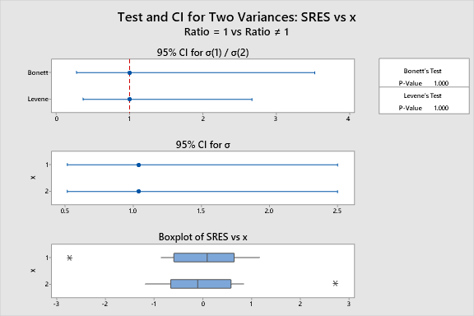

**Descriptive Statistics**

* Both groups have an identical **standard deviation** of **1.042** and a **variance** of **1.086**.
* The 95% confidence interval for the standard deviation ranges from **0.518 to 2.504**, suggesting that the data points' spread is consistent across both groups.

**Ratio of Standard Deviations**

* The estimated **ratio of the standard deviations** is **1**, indicating no difference in variability between the two groups.
* The **Bonett's 95% confidence interval** for the ratio ranges from **0.283 to 3.533**, and the **Levene's 95% confidence interval** ranges from **0.374 to 2.677**. These intervals suggest that while the true ratio could vary widely, the central estimate supports the idea of equal variances.

**Hypothesis Tests**

* **Null Hypothesis (H₀):** The standard deviations of the two groups are equal (σ₁ / σ₂ = 1).
* **Alternative Hypothesis (H₁):** The standard deviations of the two groups are not equal (σ₁ / σ₂ ≠ 1).
* **Significance Level (α):** 0.05.

**Results:**

* **Bonett's Method:** Using a p-value of 1.000, the test statistic is 0.00. We are unable to reject the null hypothesis since the p-value is significantly higher than 0.05, suggesting that there is no discernible difference in the standard deviations between the two groups.
* **Levene's Method:** The p-value is 1.000 and the test statistic is 0.00. Likewise, we are unable to reject the null hypothesis because the p-value is significantly higher than 0.05, indicating that there is no significant difference in the standard deviations between the two groups.

**Q2.**

|  |  |  |  |  |
| --- | --- | --- | --- | --- |
| **Rabbit** | **Type of insulin** | | | |
| I | | II | |
| **Dose level** | | **Dose level** | |
| Low | High | Low | High |
| A | 88 | 47 | 76 | 63 |
| B | 89 | 51 | 74 | 65 |
| C | 86 | 54 | 79 | 62 |
| D | 81 | 59 | 72 | 68 |



Descriptive Statistics: Response

Results for Insulin = I

Statistics

|  |  |  |  |  |  |  |  |  |  |  |  |
| --- | --- | --- | --- | --- | --- | --- | --- | --- | --- | --- | --- |
| **Variable** | **Dose** | **N** | **N\*** | **Mean** | **SE Mean** | **StDev** | **Minimum** | **Q1** | **Median** | **Q3** | **Maximum** |
| Response | High | 4 | 0 | 52.75 | 2.53 | 5.06 | 47.00 | 48.00 | 52.50 | 57.75 | 59.00 |
|  | Low | 4 | 0 | 86.00 | 1.78 | 3.56 | 81.00 | 82.25 | 87.00 | 88.75 | 89.00 |

Results for Insulin = II

Statistics

|  |  |  |  |  |  |  |  |  |  |  |  |
| --- | --- | --- | --- | --- | --- | --- | --- | --- | --- | --- | --- |
| **Variable** | **Dose** | **N** | **N\*** | **Mean** | **SE Mean** | **StDev** | **Minimum** | **Q1** | **Median** | **Q3** | **Maximum** |
| Response | High | 4 | 0 | 64.50 | 1.32 | 2.65 | 62.00 | 62.25 | 64.00 | 67.25 | 68.00 |
|  | Low | 4 | 0 | 75.25 | 1.49 | 2.99 | 72.00 | 72.50 | 75.00 | 78.25 | 79.00 |

**Visualizing the Interaction:**

Blood sugar levels are greater in response to low doses of insulin I than in response to high doses.   
Similar to Insulin I, blood sugar levels are greater at low dosages of Insulin II, but there is less of a difference between low and high doses.

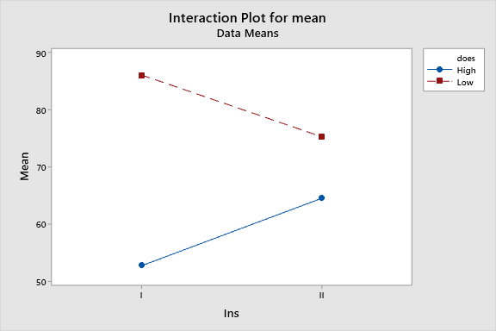

**Interaction Effect:**

When the impact of one component is contingent upon the degree of another, an interaction takes place. The interaction plot in this instance shows that the kind of insulin used determines how the dose level affects blood sugar levels. Insulin I specifically causes a greater drop in blood sugar levels when administered at large doses as opposed to Insulin II. Given that there are differences in the amount of blood sugar that each kind of insulin causes to vary, this points to a major interaction between insulin type and dose level.

* 1. Analysis of Variance

Method

|  |  |
| --- | --- |
| Factor coding | (-1, 0, +1) |

Factor Information

|  |  |  |  |
| --- | --- | --- | --- |
| **Factor** | **Type** | **Levels** | **Values** |
| Insulin | Fixed | 2 | I, II |
| Dose | Fixed | 2 | High, Low |
| Rabbit | Fixed | 4 | A, B, C, D |

Analysis of Variance

|  |  |  |  |  |  |
| --- | --- | --- | --- | --- | --- |
| **Source** | **DF** | **Adj SS** | **Adj MS** | **F-Value** | **P-Value** |
| Insulin | 1 | 1.00 | 1.00 | 0.06 | 0.815 |
| Dose | 1 | 1936.00 | 1936.00 | 112.23 | 0.000 |
| Rabbit | 3 | 7.25 | 2.42 | 0.14 | 0.933 |
| Insulin*Dose | 1 | 506.25 | 506.25 | 29.35 | 0.000 |
| Error | 9 | 155.25 | 17.25 |  |  |
| Total | 15 | 2605.75 |  |  |  |

**Main Effects**

1. **Insulin:**
   * **Null Hypothesis:** There is no difference in blood sugar levels between the two types of insulin.
   * **Alternative Hypothesis:** There is a difference in blood sugar levels between the two types of insulin.
   * **Decision:** P-Value = 0.815. **Fail to reject H₀.** There is no significant difference in blood sugar levels between the two types of insulin.
2. **Dose:**
   * **Null Hypothesis:** There is no difference in blood sugar levels between the low and high dose levels.
   * **Alternative Hypothesis:** There is a difference in blood sugar levels between the low and high dose levels.
   * **Decision:** P-Value = 0.000. **Reject H₀.** There is a significant difference in blood sugar levels between the low and high dose levels.
3. **Rabbit:**
   * **Null Hypothesis:** There is no difference in blood sugar levels among the rabbits.
   * **Alternative Hypothesis:** There is a difference in blood sugar levels among the rabbits.
   * **Decision:** P-Value = 0.933. **Fail to reject H₀.** There is no significant difference in blood sugar levels among the rabbits.

**Interaction Effect**

1. **Insulin Dose:**
   * **Null Hypothesis:** There is no interaction effect between insulin type and dose level on blood sugar levels.
   * **Alternative Hypothesis:** There is an interaction effect between insulin type and dose level on blood sugar levels.
   * **Decision:** P-Value = 0.000. **Reject H₀.** There is a significant interaction effect between insulin type and dose level on blood sugar levels.
   1. Model Summary

|  |  |  |  |
| --- | --- | --- | --- |
| **S** | **R-sq** | **R-sq(adj)** | **R-sq(pred)** |
| 4.15331 | 94.04% | 90.07% | 81.17% |

**Interpretation:**

The model accounts for **94.04%** of the range in blood sugar levels. This indicates that 94.04% of the variation in the blood sugar readings can be explained by the independent factors (insulin type, dosage amount, rabbit, and their interaction).

* 1. Findings

An Account of the Best Insulin Type and Dosage Level to Lower Blood Sugar in Rabbits   
  
The effects of two insulin types (Type I and Type II) and two dose levels (Low and High) on the blood sugar levels of rabbits were examined in an experiment. Every treatment combination was given to each of the four employed rabbits at random.

**Findings**:

**Dose Level:** Higher doses significantly reduced blood sugar levels (P-Value = 0.000).

**Insulin Type:** No significant difference between insulin types alone (P-Value = 0.815).

**Interaction Effect:** There was a significant interaction between insulin type and dose (P-Value = 0.000).

**Conclusion:** The best treatment for reducing blood sugar levels is Type I insulin at a high dose. This combination resulted in the lowest blood sugar levels, making it the most effective.

e)

**Advantages:**

1. **Time Efficiency:** Treating four different groups simultaneously can save time, as there’s no need to wait between treatments.
2. **Reduced Carryover Effects:** Using separate groups eliminates the risk of one treatment affecting the outcome of another within the same rabbit, leading to clearer results.
3. **Simpler Logistics:** Managing each group with only one treatment can simplify the administration and monitoring process.

**Disadvantages:**

1. **Increased Variability:** Different groups can introduce variability due to individual differences among rabbits, potentially confounding the results.
2. **Larger Sample Size Needed:** To maintain statistical power, more rabbits are required when using separate groups for each treatment.
3. **Potential for Imbalanced Groups:** Random assignment can lead to imbalances in characteristics like health or age, which could affect the results and make it harder to ensure comparability.

**Q3)**

|  |  |  |  |  |  |  |
| --- | --- | --- | --- | --- | --- | --- |
| **Replicate** | **Treatments** | | | | | |
| A | | B | | C | |
| y | x | y | x | y | x |
| **1** | 27 | 10 | 26 | 40 | 24 | 11 |
| **2** | 23 | 22 | 28 | 34 | 22 | 15 |

**Hypotheses for the Covariate X**

* **Null Hypothesis (H₀):** The covariate X has no effect on the response variable Y (H₀: β = 0).
* **Alternative Hypothesis (H₁):** The covariate X has a significant effect on the response variable Y (H₁: β ≠ 0).

**Hypotheses for the Treatments**

* **Null Hypothesis (H₀):** The adjusted means of the response variable Y are the same across all treatments (A, B, C) after controlling for the covariate X (H₀: τₐ = τᵦ = τ꜀).
* **Alternative Hypothesis (H₁):** At least one of the adjusted means of the response variable Y is different across the treatments after controlling for the covariate X (H₁: At least one τᵢ (for i = A, B, C) is different).

**ANCOVA Model**

The Analysis of Covariance (ANCOVA) model can be represented as:

yij=μ+τi+β(xij−xˉ)+ϵijy_{ij} = \mu + \tau_i + \beta (x_{ij} - \bar{x}) + \epsilon_{ij}yij​=μ+τi​+β(xij​−xˉ)+ϵij​

Where:

* yijy_{ij}yij​ = The jth observation on the ith treatment
* μ\muμ = Grand mean
* τi\tau_iτi​ = Effect of the ith treatment
* β\betaβ = Slope coefficient for the covariate
* xijx_{ij}xij​ = The jth observation of the covariate for the ith treatment
* xˉ\bar{x}xˉ = Mean of the covariate
* ϵij\epsilon_{ij}ϵij​ = Random error

**Findings**

1. **Effect of Covariate X:**
   * The covariate X has a significant impact on the response variable Y (**P-Value = 0.009**). Thus, we reject the null hypothesis (H₀: β = 0) and accept the alternative hypothesis (H₁: β ≠ 0), indicating that X significantly affects Y.
2. **Effect of Treatments:**
   * The treatments (A, B, C) significantly affect the response variable Y after controlling for the covariate X (**P-Value = 0.009**). Therefore, we reject the null hypothesis (H₀: τₐ = τᵦ = τ꜀) and accept the alternative hypothesis (H₁: At least one τᵢ (for i = A, B, C) is different), indicating that at least one treatment has a different effect on Y.

Model Summary

|  |  |  |  |
| --- | --- | --- | --- |
| **S** | **R-sq** | **R-sq(adj)** | **R-sq(pred)** |
| 0.319438 | 99.27% | 98.18% | 94.05% |

**R-squared (R-sq):** • The R-squared value is 99.27%, which means our model explains 99.27% of the variation in the response variable Y. This is an excellent fit, showing that the model works really well with the data.

In other words, the ANCOVA model, which includes both the covariate X and the treatments (A, B, C), does a great job of explaining the differences in Y. The model is highly effective and should make reliable predictions with new data. This suggests that both the covariate and treatments have a significant impact on the response variable.

**Validity of model assumptions**

**Probability Plot of SRES**

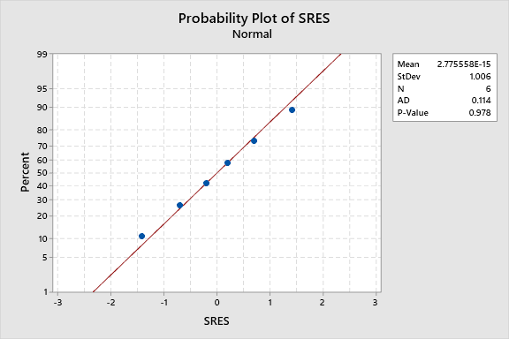

Hypotheses for Normality Test:

• Null Hypothesis (H₀): The residuals are normally distributed.

• Alternative Hypothesis (H₁): The residuals are not normally distributed.

At 0.978, the p-value is much higher than 0.05. This indicates that there is insufficient data to rule out the null hypothesis. Thus, the normality condition for our model is satisfied by the residuals' appearance as being regularly distributed.

**Runs Test: SRES**

**Descriptive Statistics**

|  |  |  |  |
| --- | --- | --- | --- |
|  | | **Number of Observations** | |
| **N** | **K** | **≤ K** | **> K** |
| 6 | 0.0000000 | 3 | 3 |

**Test**

|  |  |  |  |  |
| --- | --- | --- | --- | --- |
| Null hypothesis | | H₀: The order of the data is random | | |
| Alternative hypothesis | | H₁: The order of the data is not random | | |
| **Number of Runs** | | |  |
| **Observed** | **Expected** | | **P-Value** |
| 5 | 4.00 | | 0.361 |

**Hypotheses for Randomness Test:**

• Null Hypothesis (H₀): The order of the data is random.

• Alternative Hypothesis (H₁): The order of the data is not random.

We don't have enough evidence to reject the null hypothesis, with a p-value of 0.361. This implies that the data seem to be in a random order.

**Test and CI for Two Variances: SRES vs m**

|  |
| --- |
| σ₁: standard deviation of SRES when m = 1 |
| σ₂: standard deviation of SRES when m = 2 |
| Ratio: σ₁/σ₂ |
| The Bonett and Levene's methods are valid for any continuous distribution. |

|  |  |  |  |  |
| --- | --- | --- | --- | --- |
| **m** | **N** | **StDev** | **Variance** | **95% CI for σ** |
| 1 | 3 | 1.062 | 1.127 | (0.156, 20.857) |
| 2 | 3 | 1.062 | 1.127 | (0.156, 20.857) |

**Descriptive Statistics**

**Ratio of Standard Deviations**

|  |  |  |
| --- | --- | --- |
| **Estimated Ratio** | **95% CI for Ratio using Bonett** | **95% CI for Ratio using Levene** |
| 1 | (0.195, 5.138) | (*, *) |

**Test**

|  |  |  |  |  |  |
| --- | --- | --- | --- | --- | --- |
| Null hypothesis | | | H₀: σ₁ / σ₂ = 1 | | |
| Alternative hypothesis | | | H₁: σ₁ / σ₂ ≠ 1 | | |
| Significance level | | | α = 0.05 | | |
|  | | |  | | |
| **Method** | **Test Statistic** | **DF1** | | **DF2** | **P-Value** | |
| Bonett | 0.00 | 1 | |  | 1.000 | |
| Levene | 0.00 | 1 | | 4 | 1.000 | |

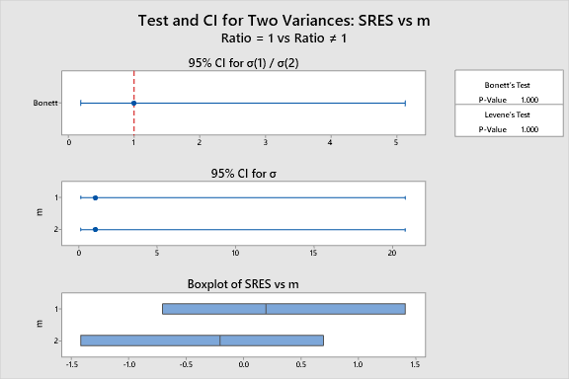

**1.Bonett’s Test:**

* Null Hypothesis (H₀): The ratio of the variances (σ₁/σ₂) is equal to 1, i.e., the

variances are equal.

* Alternative Hypothesis (H₁): The ratio of the variances (σ₁/σ₂) is not equal to 1, i.e.,

the variances are different.

**2. Levene’s Test:**

* Null Hypothesis (H₀): The variances are equal.
* Alternative Hypothesis (H₁): The variances are different.

**P-Values:**

* 1.000 is the P-value for Levene's and Bonett's tests.
* Since the alpha level (α) for both tests is 0.05, these P-values are significantly higher than 0.05, which prevents us from rejecting the null hypothesis.

**Conclusion:**

* As neither test allows us to reject the null hypothesis, there is no compelling evidence to support the idea that the SRES variances for m=1 and m=2 differ.
* Consequently, when factor m is either 1 or 2, we can say that the variances of the standardized residuals are equal.This validates the model's premise of equal variances.